**Code Snippets**

1. **Write an example for adding elements to Queue.**

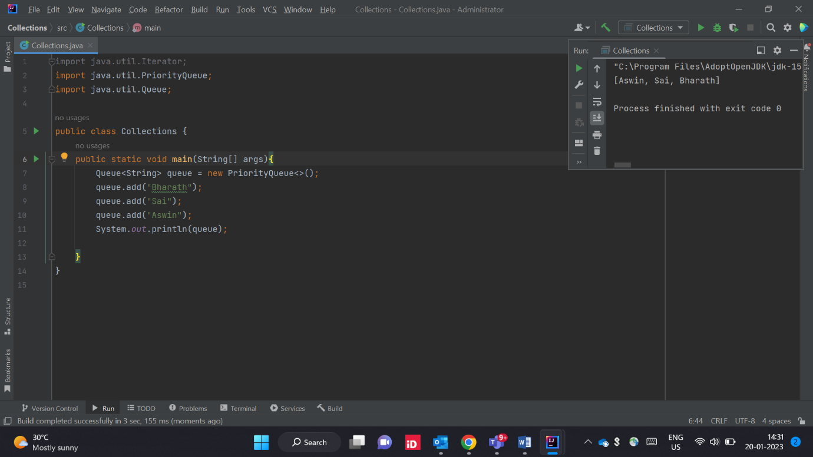

1. **Write an example for removing elements from the Queue.**

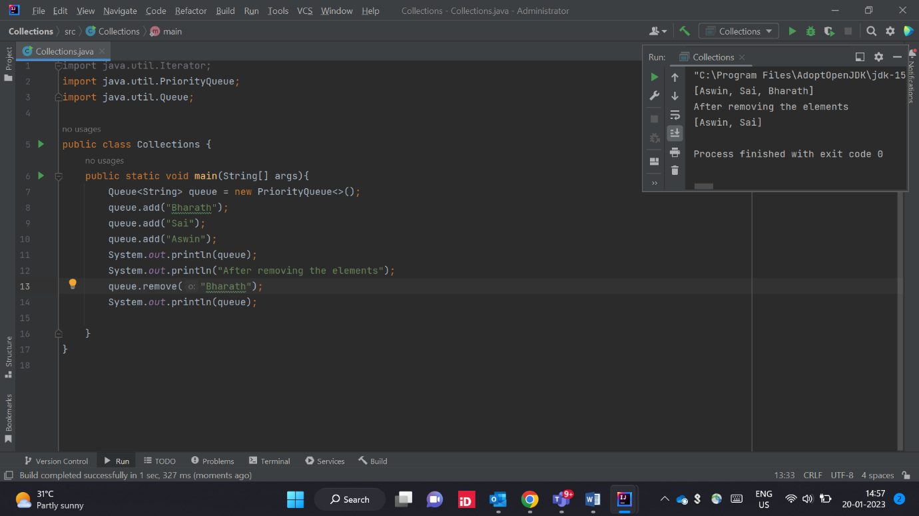

1. **Write an example using Iterating the Queue.**

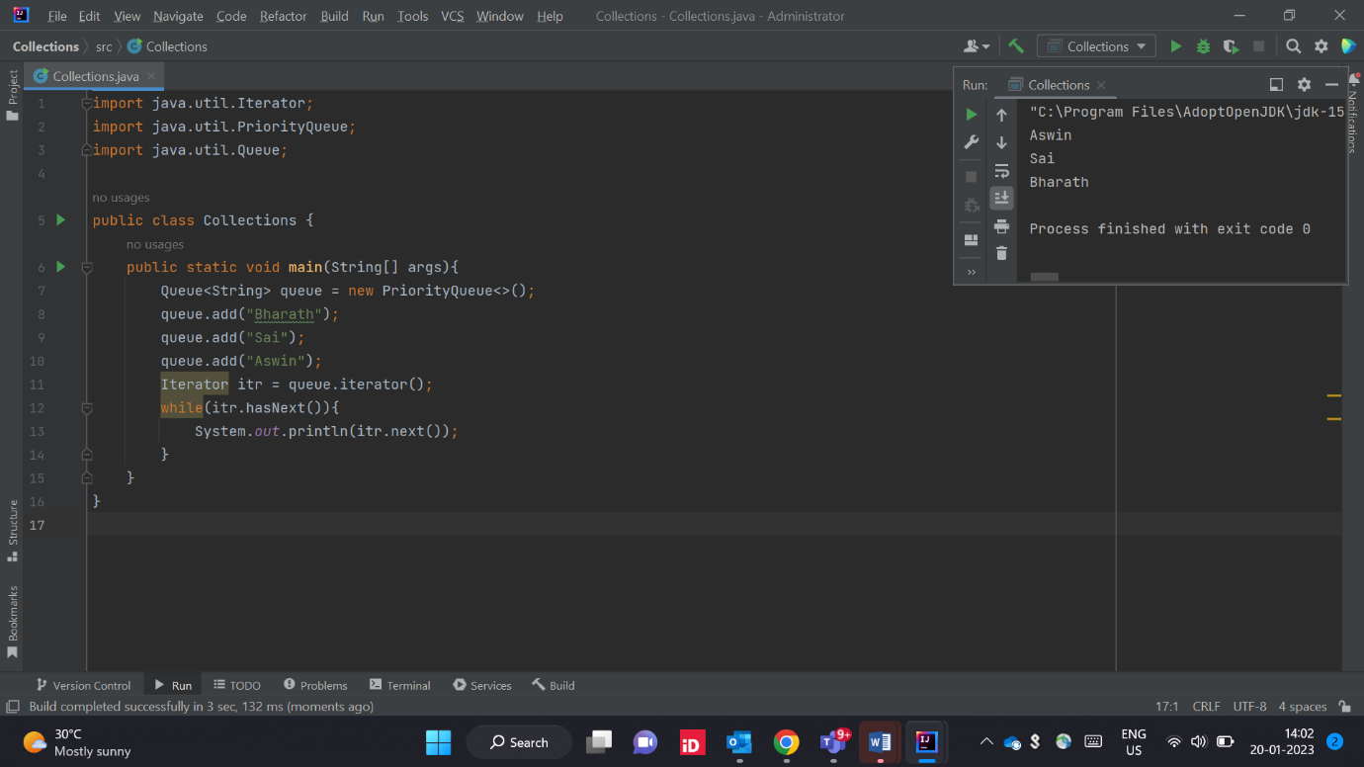

1. **Write an example using PriorityQueue class.**

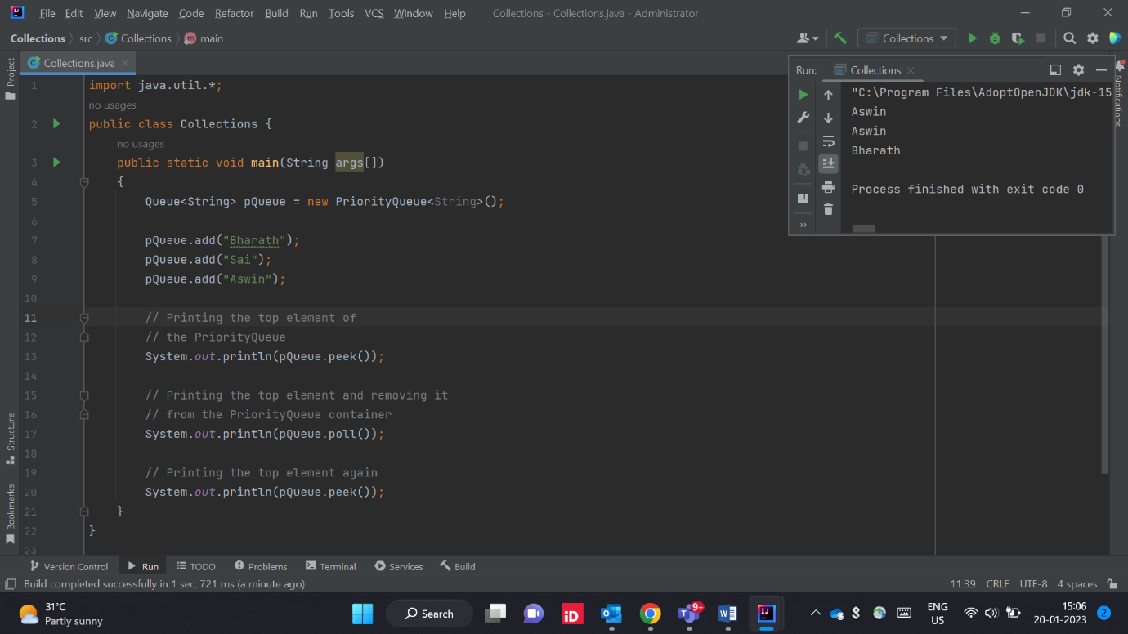

1. **Write an example using LinkedList class.**

